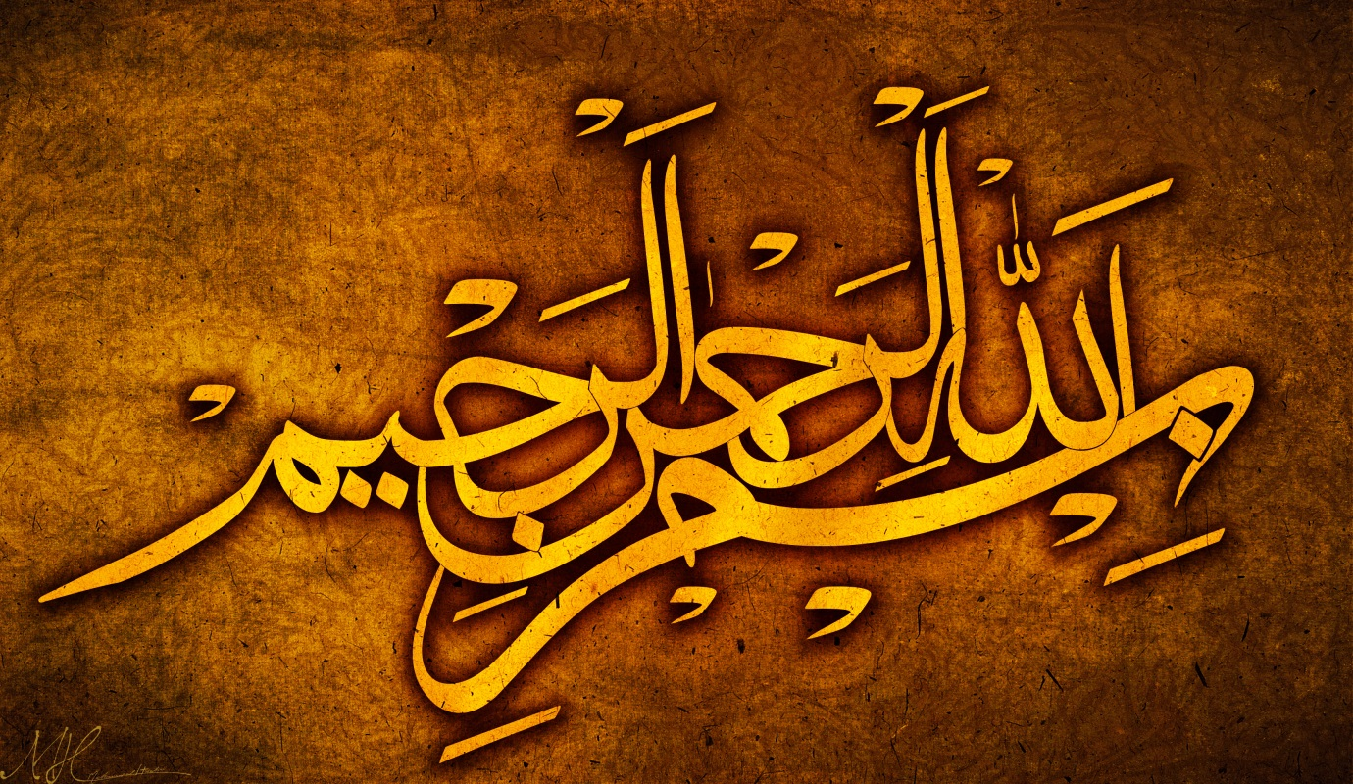
THE NAME OF ALLAH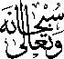INSIDE A MOOLI [WHITE RADISH]
The Exclusive Islamic Miracle Photographs of Dr Umar Elahi Azam
Tuesday 8th September 2015
Manchester, UK

Introduction
The Name of Allah was clearly visible, artistically inside a mooli or white radish.
